NAME: __________________________ DATE DUE: ____________
TEACHER: ________________________
/20
Year 9 Term 4 – Body Systems
HOMEWORK SHEET No. 4 – Learning Goal 4

 | - Write a definition for each of the following terms:
/1 | (a) Respiration –
/1 | (b) Inhalation –
/1 | (c) Exhalation -
/1 | (d) Diffusion -
/4 | 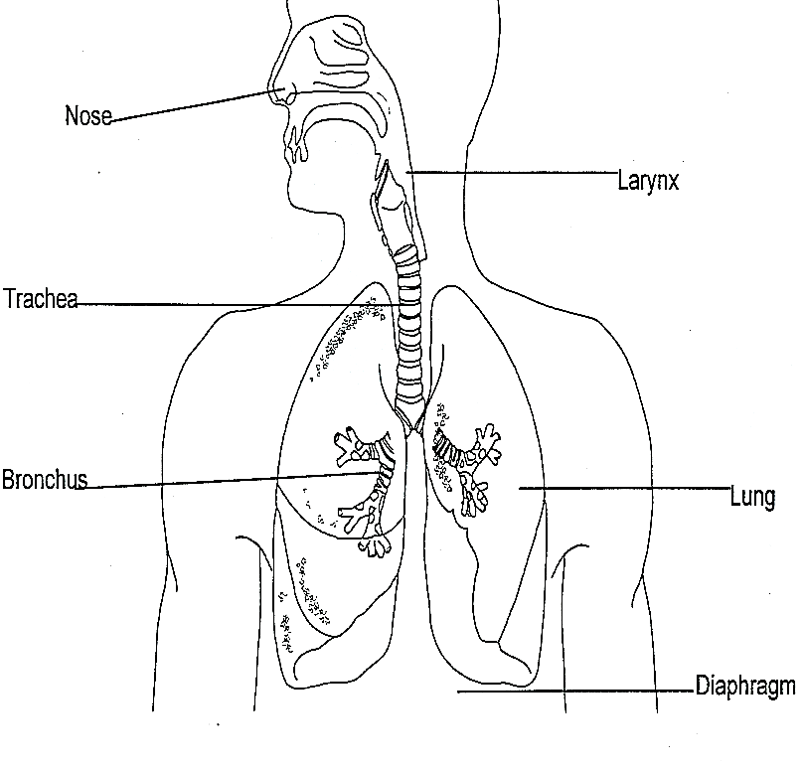  - In each of the text boxes describe the main role(s) of the four named parts of the respiratory system  Role of the Diaphragm:  Role of the Trachea:  Role of the Cilia lining the respiratory system:  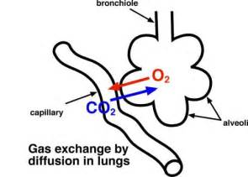  Role of the Alveoli:

/5 | - Use the highlighted words to complete the three sentences below them. Each word is used once.  Capillary Higher Diffuse Capillary Lower Higher Diffusion Lower Surface area  Oxygen molecules …………………across the lining of the alveolus into the blood in the………….., moving from ……………………..to …………………….concentration.  Carbon dioxide molecules diffuse across the lining of the ………………. out of the blood into the alveolus, moving from ……………………..to …………………………concentration.  The large number of alveoli increases the ……….. …….. of the lungs and therefore increases the rate of ………………………….
/3 | 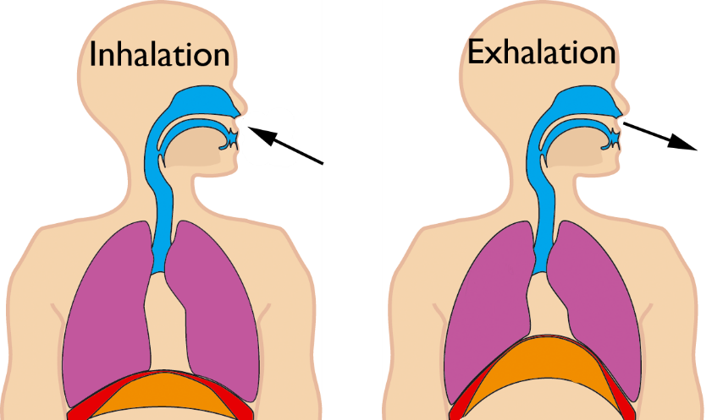  - Label and annotate (write a description of) the diagram below explaining the process of breathing. The movement of the diaphragm should form a big part of your answer
/4 | - Use the labels in the list below to create a flow chart showing the passage of oxygen and carbon dioxide through the respiratory and circulatory system.  LIST: heart, heart, lungs, lungs, trachea, trachea, alveoli, alveoli,  aorta, vena cava, alveolar capillary, body capillary, pulmonary vein, pulmonary artery  Mouth/nose  Body cells  Mouth/nose  O₂  CO₂

